# Tigray Martyrs' Memorial Monument Center

# Electronic Documents Management System (E-DMS)

User Manual

Prepared By: *Mekelle University EDMS Project Team*

Date: *July 8, 2020*

## About The System

Electronic Document Management System (E-DMS) is a framework of tools for managing the creation, use and storage of digital documents that are available within the organization. The main purpose of this E-DMS system is to provide a central repository for digital documents located within Tigray Martyr’s Memorial Monument Center.

It is mainly used for:

* Storage of digital assets in a centralized and secure environment. These digital documents can have several formats (Video, Audio, Image, and Text).
* Immediate web based access to documents by authorized personnel from any location
* Multiple users can access the same document simultaneously, at anytime
* Management of versions of documents to minimize inconsistency and redundancy
* Increased speed of storing, retrieving and modifying documents
* Reduction of paper, space and staffing requirements associated with paper filing systems

Purpose of this User Manual  
This manual should be used as a guide by all users, while uploading, searching, downloading , sharing and approving digital documents.

System Modules

Main Modules of the System are:

* User Management Module
* Access Control Module
* Digital Document Uploading Module
* Digital Document Searching Module
* Digital Document Display Module
* Digital Document Downloading Module
* Digital Document Sharing Module
* Action Tracking Module
* Permission and Security Module
* Reporting Module

To Access the system open browser (Google chrome is recommended) and type the URL Example: *<ip-address>:<port>/EDMS* and you will see the page below

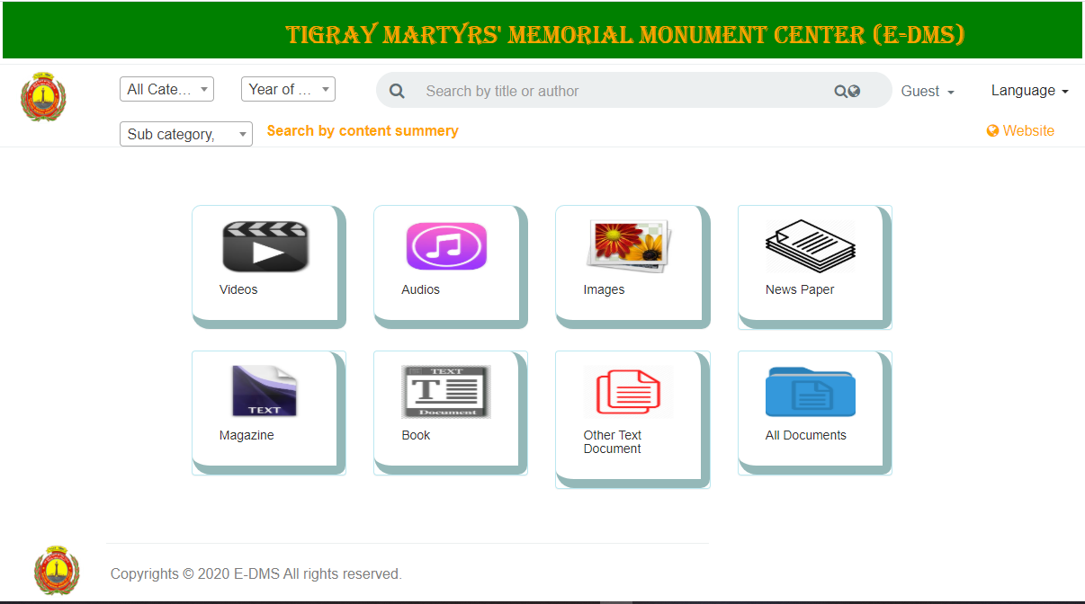

After you click on one of the categories a list of documents in that category will be displayed

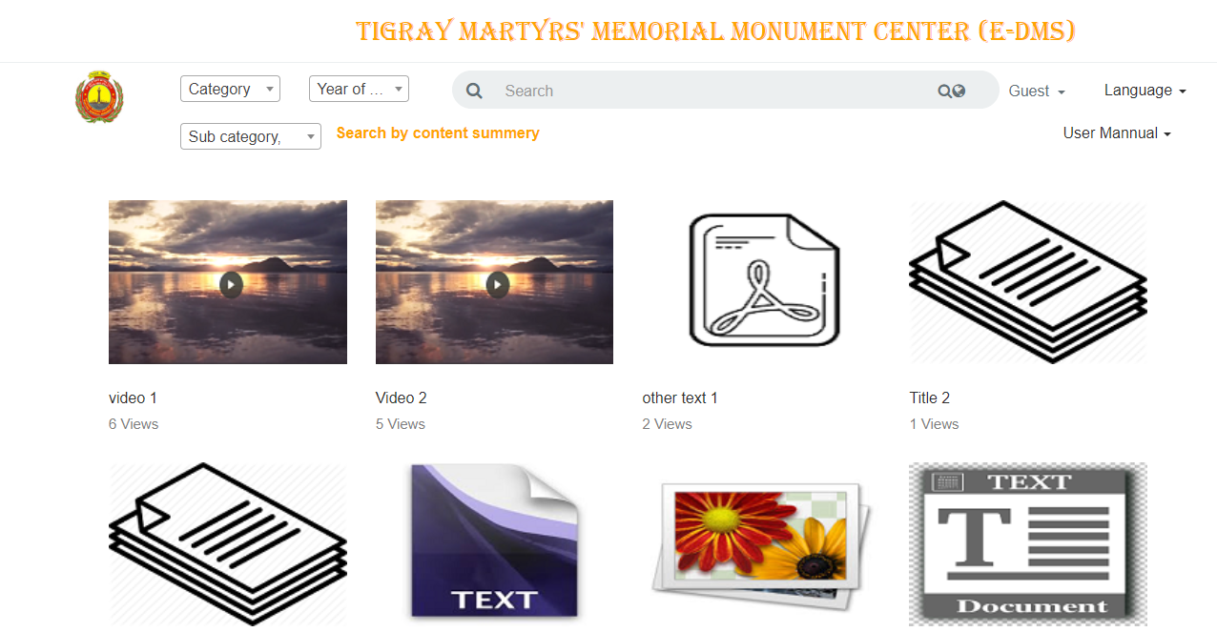

# **Login**

To login in to the system

Click on Guest > Sign In link

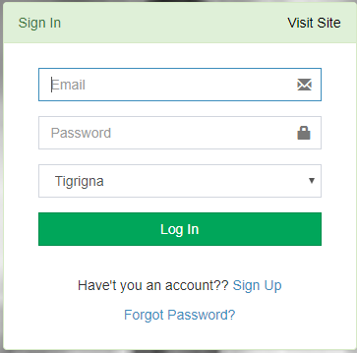

* Enter your Email or Username and Password
* Select Language
* Click “Log In” Button

# Admin Dashboard

After successful login you will be redirected to the dashboard page with sidebar containing list of permitted actions and dashboard icons with brief statistical data showing the number of registered users/documents and awaiting new documents/users for approval

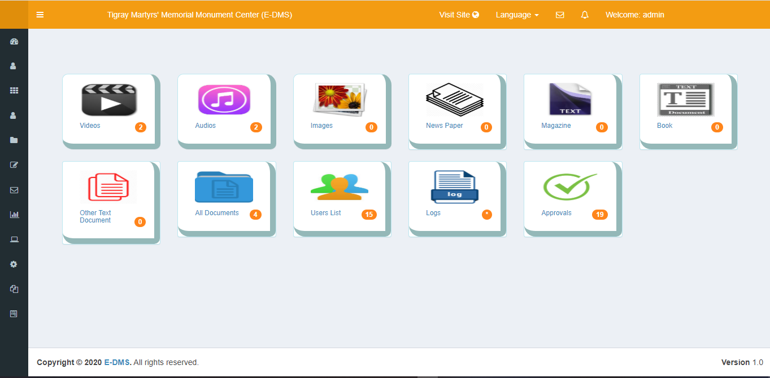

The main Navigation Menu containing action links according user access permissions looks like

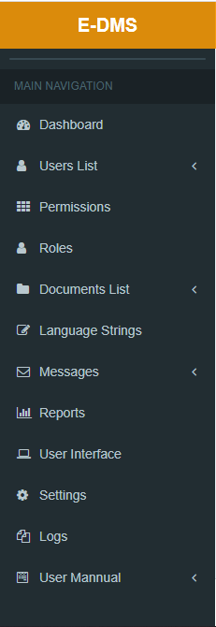

User Types/Roles Menu  
User Types page where you can add, edit and delete roles.

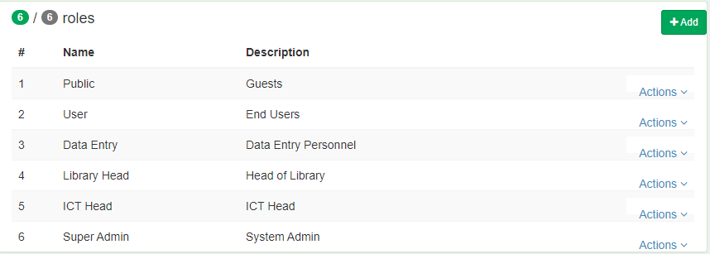

There are 6 main types of user types/roles on this system listed below.

**N.B** Any User Type such as Library Head, ICT Head, Data Entry or any other can be created and granted access permissions or get deleted by system admin at any time.

User Types/Roles Description  
**System Admin**   
The administrator of this system who has the overall access of the system. which is the main and most powerful user in the system with the capabilities of:

* Create new Roles
* Assign Permissions to Roles
* Create Users & Assigns Roles
* Upload Digital Documents
* Approve Uploaded Documents
* View Summarized Data

Library Head  
The user of this system who is responsible for approval of document permissions. Additional actions could also be granted by the administrator.

# Data Entry

The user of this system who is responsible for uploading documents. Additional actions could also be granted by the administrator.

ICT Head  
The user of this system who is responsible for setting up the system. Additional actions could also be granted by the administrator.

User  
The user of this system who has signed up by its own and allowed to sign in after approved by administrator.

Public User  
Anyone who visited the public pages of the system to access the public documents of the system with no identity.

Permissions Menu  
Permissions page allows you to assign and edit action permissions to roles.

* Click Permissions Link from the Main Navigation

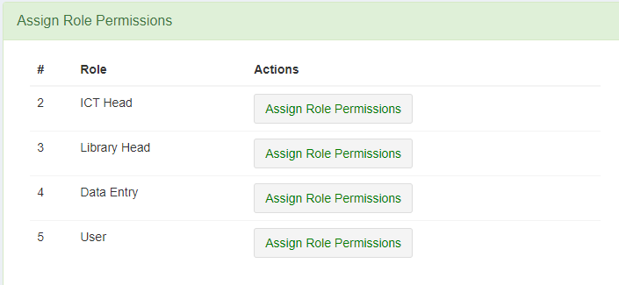

Select a Role and click on “Assign Permissions” Button

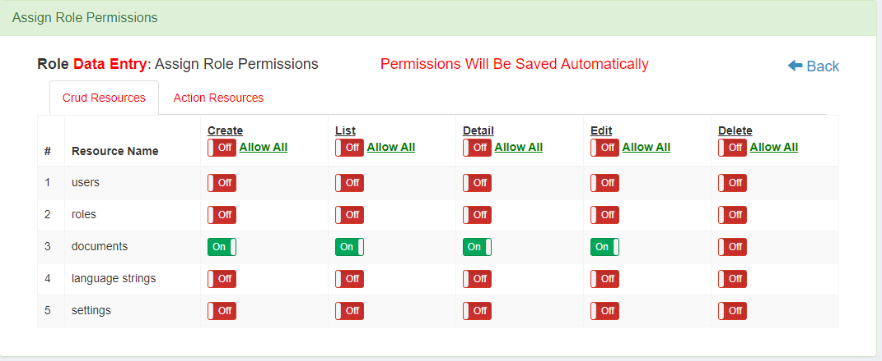

Users Menu  
Users page where you can add, edit, deactivate and delete users.

1. Add User

* Fill the form fields
* System generated password will be pre populated
* To see or change the password click on “Show Password” Button and see/change it.
* Click “Save” button.
* Email message will be sent automatically to the provided user email.
* The user must go to his/her email and get the password.

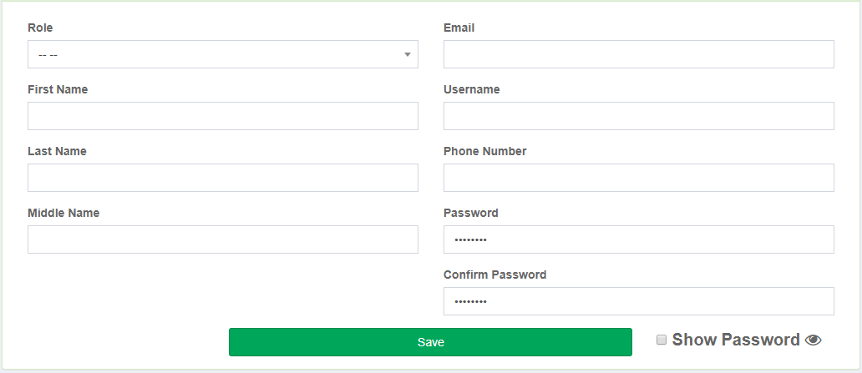

B. View, Edit, Delete and Deactivate Users

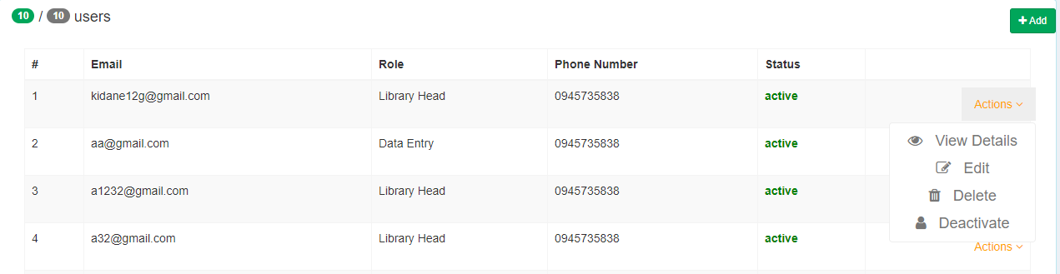

1. Approve/Reject new Users   
   Every new users should be approved by the administrator before they are allowed to sign in to the system.

* To Approve/Reject new users
* Click Users > New Users Link from the Main Navigation

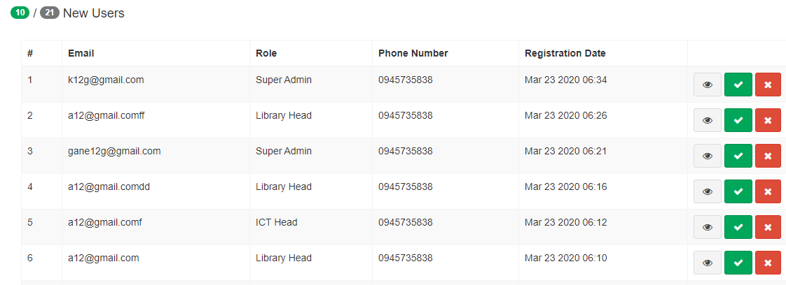

To Approve Click on the green button



To Reject Click on the red button



Document Categories:  
There are 7 document categories in this system which are listed below with their respective recommended formats.

* Video documents with recommended format MP4
* Audio documents with recommended format MP3
* Image documents with recommended format JPEG and PNG
* News Paper, Magazine, Book, Other Text documents with recommended format of PDF

Document Sub Categories:  
There are 4 document sub categories on this system listed below.

* Entertainment
* Documentary
* Interview
* Other

Documents Menu  
Documents page where you can upload, search, view, share, and delete documents.

* Click Documents link from the Main Navigation

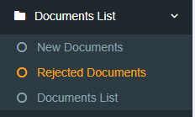

1. Documents List

* You can filter documents by title, author, publisher and year of publishment



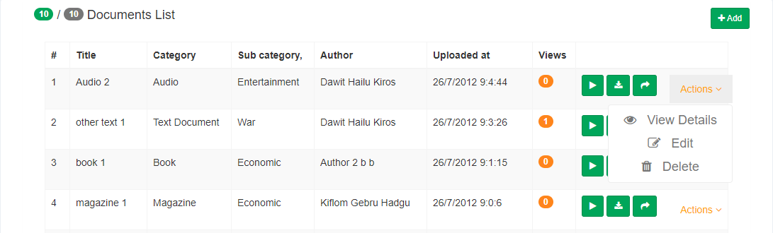

1. Upload New Document

* Click on “Add” Button and document upload form will be displayed

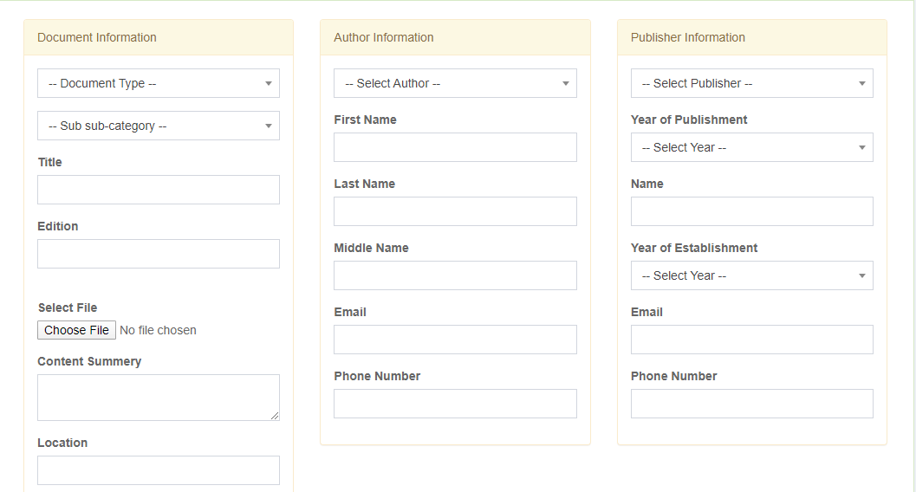

1. Approve/Reject New Uploaded Document

* Click on New Documents Link from the Main Navigation

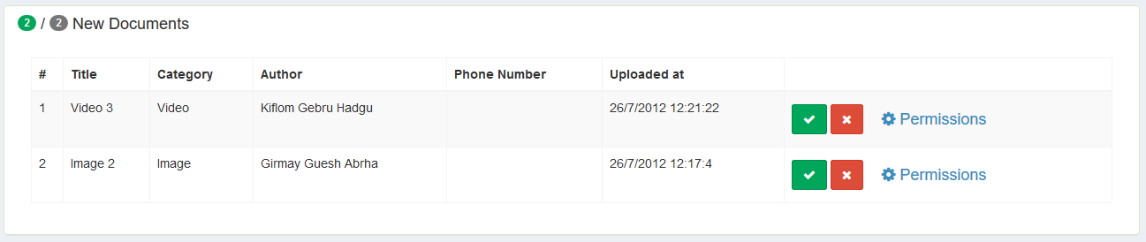

N.B before approving/rejecting of any document. Approval for the correctness of its access permissions is required.

* Click on “Permissions” Link from the Main Navigation 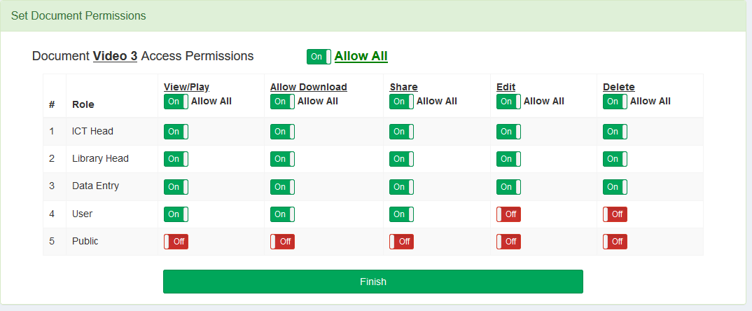
* Click on the avaliable buttons and turn on/green to allow and turn off/red to deny the permission
* After setting the appropriate document permissions to each role, click “Finish” Button. Now you have successfully set access permissions of the new document and you are allowed to approve the new document.
* For document details click on the gray button



* And to Approve it click on the green



* Or to Reject it click on the red button



1. View Details

Click on Actions > View Details button

1. Edit

Click on Actions > Edit

1. Delete

Click on Actions > Delete

1. Play



1. Download



1. Share



# Language Strings Menu

A Page that allows you to change phrases and their translation in Tigrigna, Amharic and English

* Click Language Strings Link from the Main Navigation

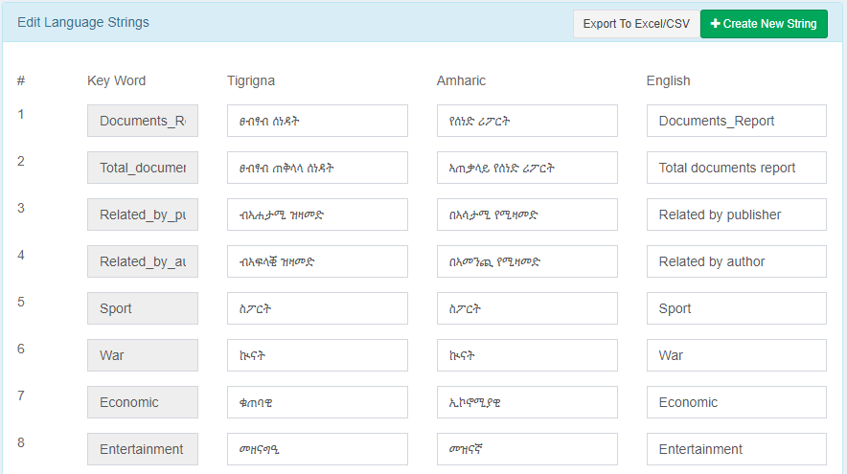

# Messages

Allows inter messaging of users with each other within the system, It enables them to send and receive messages. Notifications will be shown for unread messages



* Click Messages Link from the Main Navigation

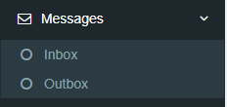

* To see inbox messages, click on Inbox
* To see outbox messages, click on Outbox

# Reports Menu

Allows to generate report and print as PDF or download in Excel based on the specified StartDate and EndDate range

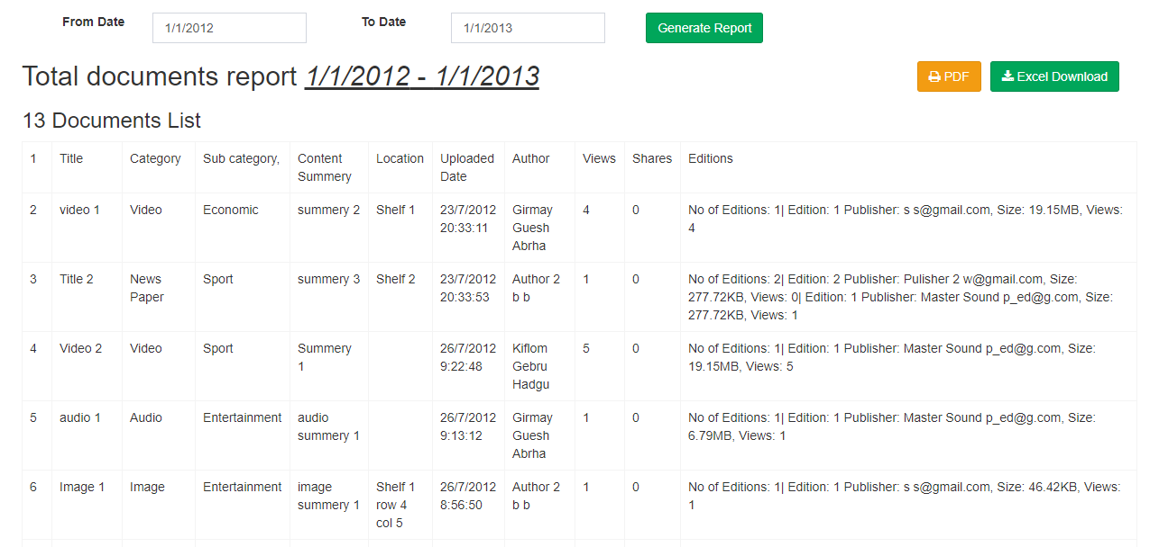

# User Interface Menu

To update User Interface of the system i.e. App Name, Logo Image, Background Image

* Click User Interface from the Main Navigation

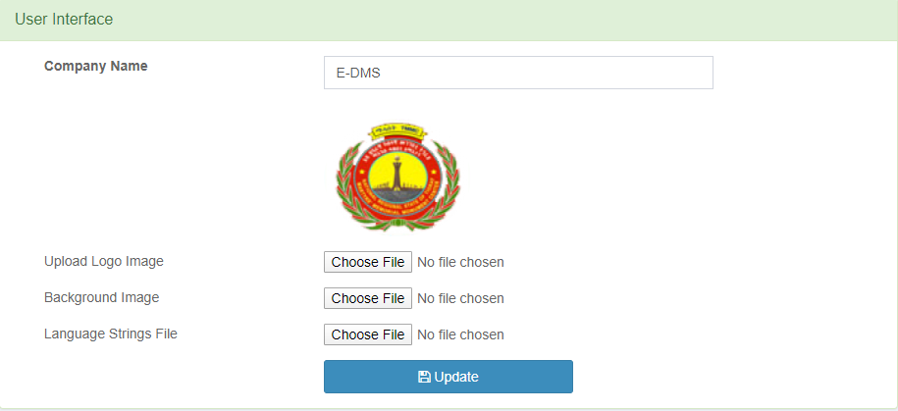

# System Settings

Allows to update system settings

* Click Settings Link from the Main Navigation

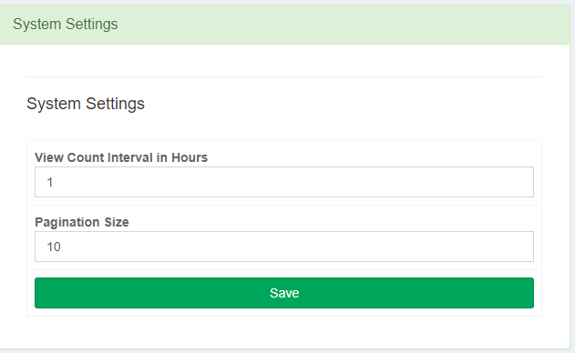

# Logs Menu

Allows to track activities performed within the System.

* Click Logs Link from the Main Navigation

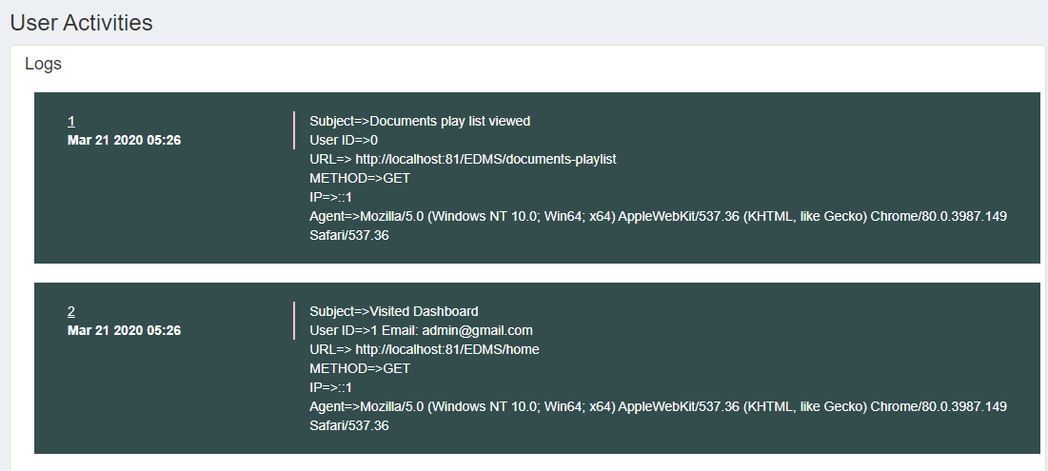

# Visit Site Option

To visit the public pages of the system and play/view their document contents

* Click on “Visit Site” Link from the Top Navigation.



All permitted documents will be available on the document gallery and you can play, download, and share according the document permissions.

# Change Current Language

To change the current language

* Click on “Language” link and choose the one you are interested in.

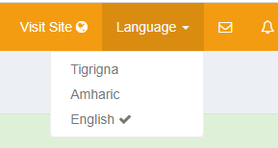

# Change Account Profile

To change your account profile

* Click on the link showing your name and click on “Profile Settings” link.

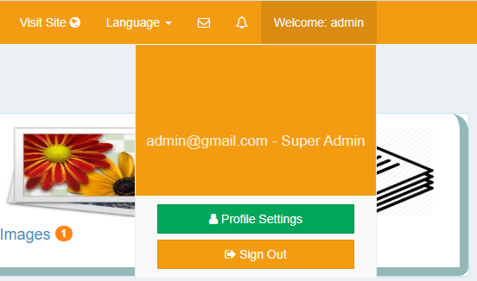

Here you can change your Username, Full Name, and Password

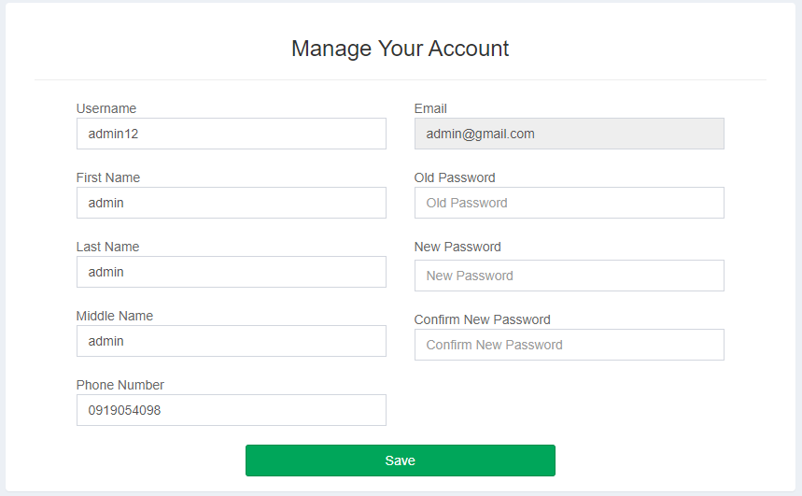

# Sign Out from the system

After completed your tasks within the system, you need to sign out from the system.

* Click on the “Sign Out” Button.



# Then the system will redirect you to the public page

# Public Users

Everyone who has access the public pages of the system, can access public documents. And can play/view, download and share them when permitted. You can find specific document by filtering by Title, Author, Publisher, Year of publishment, Category, Sub Category and Content Summery.

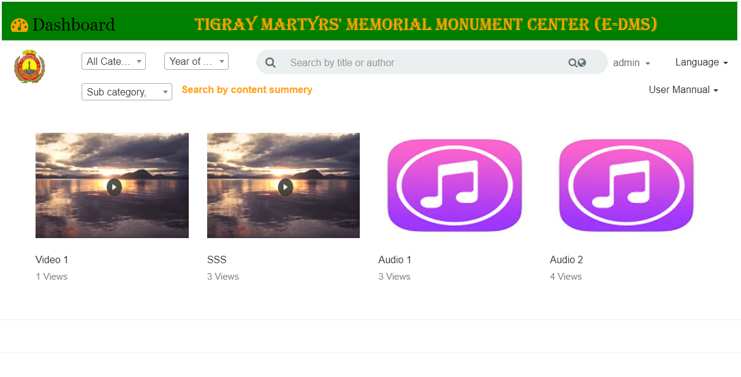

# Sign Up

Public users can also have identity by registering themselves using the sign up option. And after approved by administrator their account will be activated and allowed to Sign In.

To sign up

* Click on Guest > Sign Up link

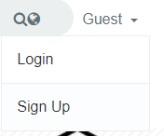

The System will redirect you to the registration page

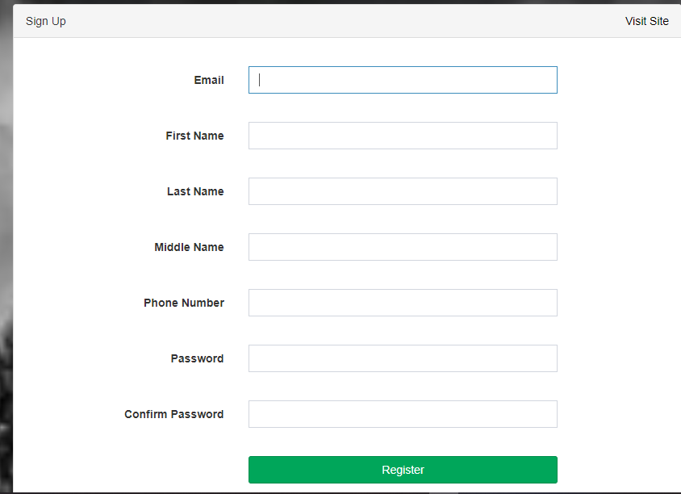

* Enter your details and click on the “Register” button.
* Now if you don’t get any errors, you are successfully registered and your account is waiting to be approved by administrator
* Sign In with your credentials i.e enter your email and password
* If your account is not approved by the administrator yet, you will get “account not activated” message.
* And if your account is approved you will be forced by the system to change the system generated password before allowing you to access anything in the system.
* Fill the old password field with the system generated password sent to your email during registration and enter a new strong password containing at least one [lowercase letter, upper case letter, digit and special character], and with length of eight or more characters. Then confirm your new password by filling it in the Confirm password field and make sure you remember your new password for later use. Now you can also set your Username for alternative login credential to email.

END OF USER MANUAL